**LAB # 09**



**Spring 2022**

**Operating Systems**

**Submitted by: Maaz Habib,Alishba Orakzai, Nida Asmat Burki**

**Registration no. 20PWCSE1952,20pwcse1953 , 20pwcse1955**

**Class Section: C**

**“On my honor, as student of University of Engineering and Technology, I have neither given nor received unauthorized assistance on this academic work.”**

**Submitted to: SIR IBAD**

**June 7, 2022**

**Department of Computer Systems Engineering**

**University of Engineering and Technology, Peshawar**

**Lab Work:**

1. First, we make file with name “cms” by “mkdir” command.
2. Then we go in the that directory by “cd cms” command.
3. After that we make another file inside cms by name of “sensitive_data” using same command that we used for making cms.
4. After that we create a “c” file my name “code.c” using “gedit” command, and we write the code. The code is for giving password to the file
5. **Code:**

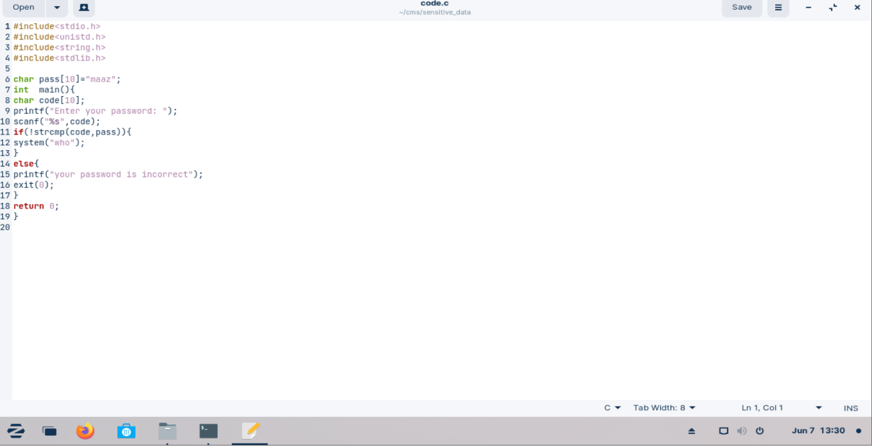

1. We also have to lock the “sensitive_data” folder, for that we use “chmod 300 sensitive_data” command.
2. Then we complie “code.c” file by “gcc code.c -o code “command.
3. We run it by “. /code” command.
4. In terminal it will ask for password: we enter the on which was in c file(maaz).
5. **Output:**

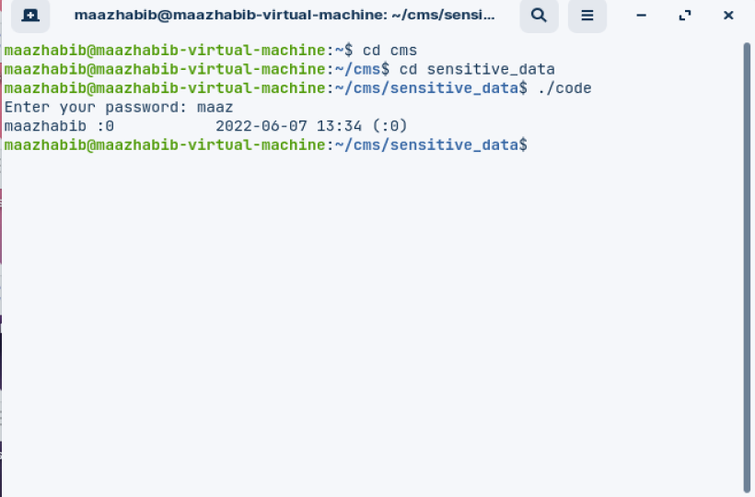

1. If we try to open it from the folder cms it asks for password, which is of administration password we enter it and can see both the files.

**Asking for password:**

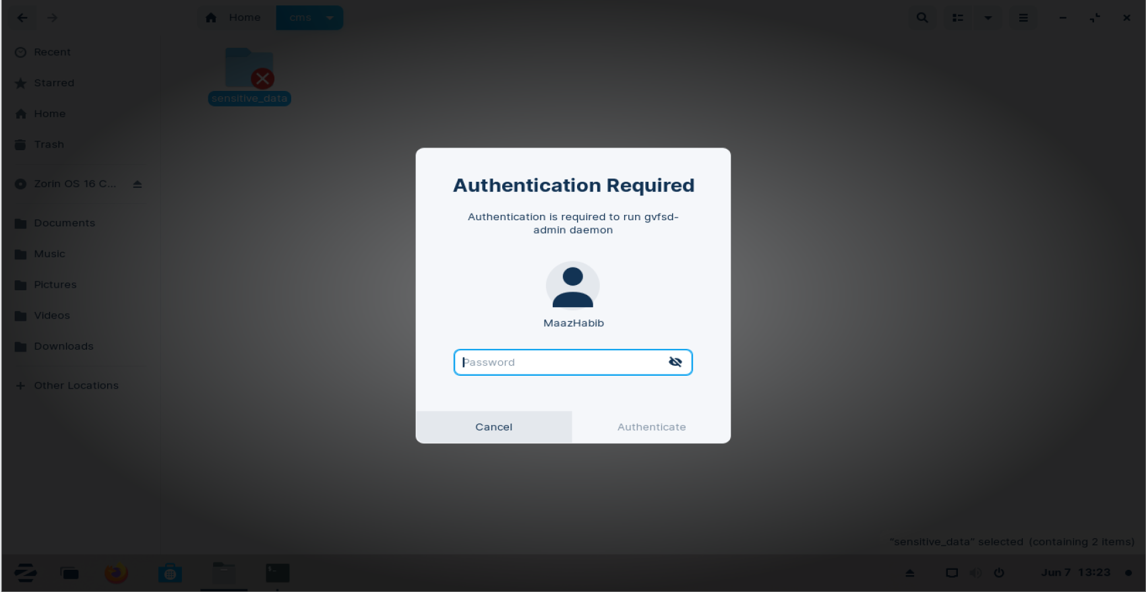

**With File Password:**

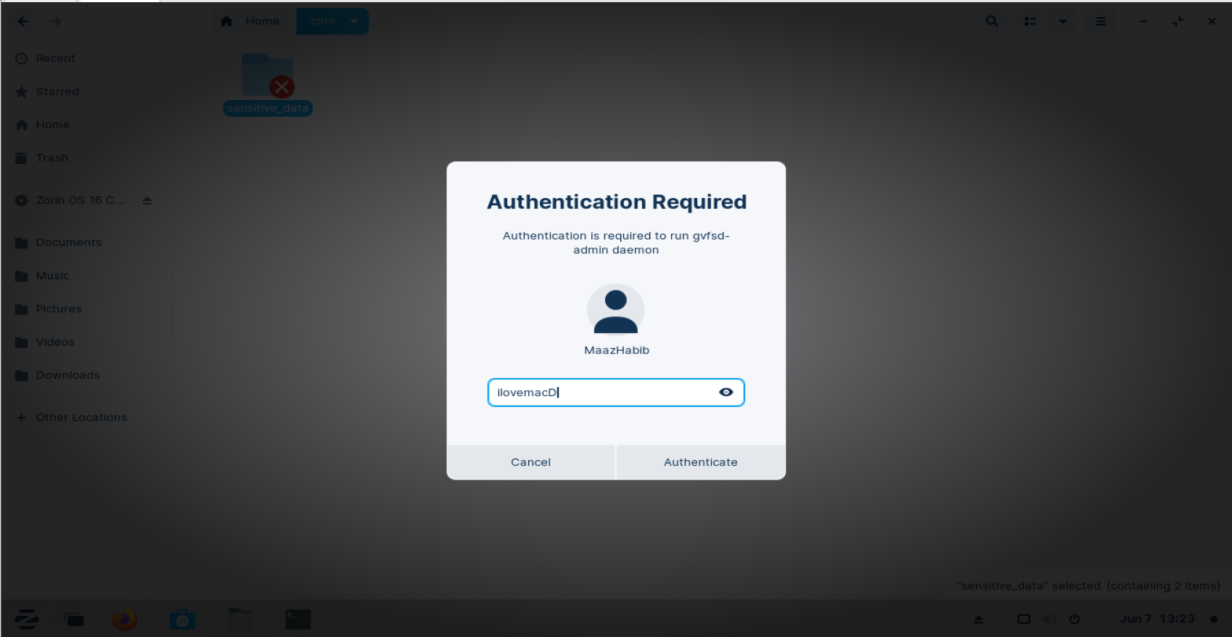

**After opening the sensitive data folder:**

